TITLE EXAMPLE: (ENVIRONMENTAL EDUCATION AND CLIMATE RESILIENCE: CONTEMPORARY CHALLENGES) Title in Arial 11, bold, capitals, centered, no period, single-spaced, not more than three lines
Extended abstracts will be accepted for the proceedings. Use this template by saving it as a *word document. Then overwrite this title and do the same in the other sections, carefully reading the instructions. Paper size is A4, margins: top and left 3cm/bottom and right 2cm.
ATTENTION: The abstract must contain a MINIMUM OF 03 PAGES TO A MAXIMUM OF 05 PAGES, CONSIDERING THE REFERENCES.

The paper can be submitted in the authors' native language (Portuguese, Spanish, French and English).
**However, after the corrections suggested by the ad hoc reviewers, the authors undertake to send, in addition to the corrected version in the native language, a mandatory version in English**
Accepted extended abstracts will be published in the event proceedings.

Leave 2 SPACES Arial 11 single-spaced between title and authors - always exclude notes, they are formatting guidelines)
Name LAST NAME
Affiliation, country and e-mail.
http://orcid.org/0000-0000-0000-0000
Name LAST NAME
Affiliation, country and e-mail.
http://orcid.org/0000-0000-0000-0000
(Orcid can be obtained free of charge by registering at: https://orcid.org/)
(Maximum number of 5 authors, aligned to the right, font Arial 10, single-spaced and separated by 6pt spacing after the orcid)

THEMATIC TOPIC: choose one and type here (e.g.: Environmental education, climate emergency, public policies and society)
(leave one space before the subtitle - delete this note)
KEYWORDS: enter three keywords, separating them by period (e.g.: word1. word2. word3.)
(leave one space before the subtitle - delete this note)
INTRODUCTION
Insert the introduction, containing background information and significance, research objective or problem statement and state of the art. Indentation in the first line (paragraph) of 1.25 cm.
(leave one space before the subtitle - delete this note)
MATERIALS AND METHODS (OR METHODOLOGY)
Insert the text referring to the methodological procedures adopted. The methodological procedures answer: How? With what? When? What? With whom? At where?
(leave one space before the subtitle - delete this note)
RESULTS AND DISCUSSION
Present information relevant to the data collected and analyzed, and compare your results with works by other author(s) (use citations).
Tables with numerical data must be open, and charts with text data must be closed. The table title should be at the top of the table, in Arial 10, single-spaced and with a 6pt space after, without bold. Tables must be referred to from the text, e.g.: “as shown in Table 1” or simply “(Table 1)”.
(leave one space - delete this note)
Table 1 - Frequency and significance test for the group of questions, for the study of environmental perception in São Joaquim, SC, Brazil. (be careful not to stay out of the margins!)
Question |  |  | N. observed |  | x² test
 |  |  | Fem. | Mas. | x² value | GL | p-value
People who would help with a financial contribution to the maintenance of your city's trees | Yes |  | 123 | 110 | 2.58 | 1 | 0.148
 | No |  | 28 | 39 | - | - | -
 | If yes: | R$ 5,00/year | 32 | 20 | 1.89 | 2 | 0.388
 |  | R$ 5,00 to 10,00/year | 26 | 23 | - | - | -
 |  | > R$ 10,00/year | 21 | 23 | - | - | -
Legend: X² = Chi-square test symbol; GL = Degree of freedom; p = Test of significance level.
Source: research data, 2021.
(leave one space - delete this note)
Source and/or legend should be at the bottom, in Arial 10, single-spaced with a 6pt spacing before it, without bold. The information inside the table or chart must be in Arial 10 and single-spaced.
The figures must also be centered. The title of the figure should be at the top of the figure, centered, not bold, in Arial 10, single-spaced and with a 6pt after spacing; the source of the figure should be at the bottom of the figure, in Arial 10, single-spaced and with a 6pt before spacing, without bold.
Attention: Center figures, title, legend (or caption) and source).
Charts, graphs, maps, photos, drawings and others are considered as figures. In the text, the figure should be cited, e.g., “as in Figure 1” or simply “(Figure 1)”.
(leave one space - delete this note)
Figure 1 – Region comprised by the Triple Border Megalopolis Project.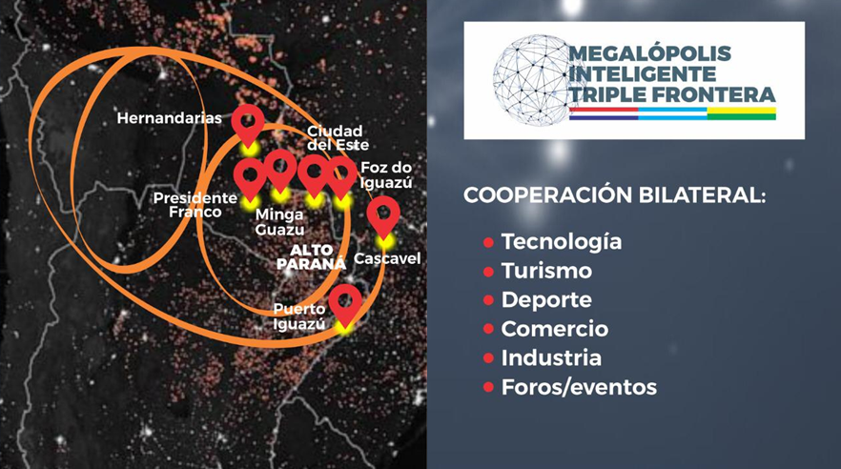
Source: Project coordinator Juan Enrique Szymankiewicz, 2021.
(leave one space - delete this note)
Charts are figures whose information is organized that do not present statistics. These must be completely closed, following the same guidelines for tables and figures, regarding the disposition of the title and source. The information inside the chart must be in Arial 10 and single-spaced.
(leave one space before the subtitle - delete this note)
CONCLUSION
Insert final comments.
(leave one space before the subtitle - delete this note)
Acknowledgments: Insert here if needed to Funding Agencies, Institutions, people, etc.
(leave one space before the subtitle - delete this note)
REFERENCES
(leave one space before the text - delete this note)
References, a mandatory element, must be prepared in accordance with ABNT NBR 6023/2018 (ABNT style, see some examples below). Guidelines for formatting: use Arial 10, single-spaced, aligned to the left; and separated by 6 pt spacing after the paragraph, alphabetically ordered and unnumbered. Use the space below only for references cited in this paper.

Journal/Magazine Article
Pattern:
[Author LAST NAME], [Author First/Middle Name Initial(s)]. [Title of the article]. [Name of the Journal/Magazine], [Publisher Location], v. [Volume Number], n. [Issue Number], p. [Page number starts]-[ends], [Publication Year].
Example:
POLAND, G.; JACOBSON, R. M. Understanding those who do not understand: a brief review of anti-vaccine movement. Vaccine, v. 19, n. 19, p. 2440-2445, 2001.

Newspaper Article
Pattern:
[Author LAST NAME], [Author First/Middle Name Initial(s)]. [Title of the article]. [Name of the Newspaper], [Publisher Location], p. [Page number starts]-[ends], [Publication Date].
If online, add: Disponível em: [URL]. Acesso em: [Date of access].
Example:
HEGARTY, S. Covid vaccine stockpiles: Could 241m doses go to waste?. BBC News, 21 set. 2021. Disponível em: https://www.bbc.com/news/world-us-canada-58640297. Acesso em: 22 set. 2021.

Book
Pattern:
[Author LAST NAME], [Author First/Middle Name Initial(s)]. [Title of the book]. [Publisher Location]: [Publisher Name], [Publication Year]. ISBN [Number].
Example:
SCHWAB, K. A quarta revolução industrial. São Paulo: Edipro, 2016.

Book chapter
Pattern:
[Chapter author LAST NAME], [Author First/Middle Name Initial(s)]. [Title of the chapter]. In: [Book author/Editor LAST NAME], [Author First/Middle Name Initial(s)]. [Title of the book]. [Publisher Location]: [Publisher Name], [Publication Year]. p. [Page number starts]-[ends]. ISBN [Number].
Example:
BECK, U. A reinvenção da política. In: BECK, U.; GIDDENS, A.; LASH, S. Modernização Reflexiva: Política, tradição e estética na ordem social moderna. Oeiras: Celta Editora, 2000. p. 1-51.

Thesis/Dissertations
Pattern:
[Author LAST NAME], [Author First/Middle Name Initial(s)]. [Title]. [Deposit Year]. [Number of pages] p. [Type of paper] ([Degree and course]) - [Institution], [Location], [Year of presentation].
Example:
MARIN, D. M. The impact of building orientation on energy usage: Using simulation software IDA ICE 4.7.1. 2017. 33 p. Tese (Mestrado em Engenharia de Energia) - University of Gävle. Faculty of Engineering and Sustainable Development, Suécia, 2017.

Published Conference Paper
Pattern:
[Author LAST NAME], [Author First/Middle Name Initial(s)]. [Title of the conference paper]. In: [TITLE OF THE CONFERENCE], [Event edition]., [Year], [Location of conference]. [Document title]... [Publisher Location]: [Publisher Name], [Publication Year].
Example:
ARAUJO, A.; CACHO, N.; GARCIA, I. et al. A platform for citizen cooperation during the Covid-19 Pandemic in RN, Brazil. In: INTERNATIONAL SMART CITIES CONFERENCE (ISC2), 6., 2020, Piscataway, NJ, USA. Proceedings… IEEE, 2020.

Technical standard/Reports
Pattern:
[Organization abbreviation] - [Organization name]. [Title: subtitle if any]. [Publisher Location]: [Publisher Name], [Publication Year]. [Number of pages] p.
Example:
ISO - International Organization for Standardization. ISO/TS 11405:2015: dentistry: testing of adhesion to tooth structure. Geneva: ISO, 2015. 12 p.
UN - United Nations. World Urbanization Prospects: the 2014 revision, highlights. New York: United Nations, 2014.

Website
Pattern:
[Organization NAME or Author LAST NAME, Author First/Middle Name Initial(s)]. [Name of the website]. Disponível em: [URL]. Acesso em: [Date of access].
Example:
CEPED UNIOESTE - CENTRO DE ENSINO, PESQUISA E EXTENSÃO EM PROTEÇÃO E DESASTRES. Início. Disponível em: https://www.unioeste.br/portal/ceped/inicio. Acesso em: 22 set. 2021.

REMINDER: This extended abstract must contain a MINIMUM OF 03 PAGES TO A MAXIMUM OF 05 PAGES, CONSIDERING THE REFERENCES.

